

**UNIVERSITY OF PETROLEUM AND ENERGY STUDIES**

**School of Computer** **Science**

**2020-21**

**GRAPHICS AND ANIMATION TOOLS LAB**

**Faculty: Dr. DURGANSH SHARMA**

**Assistant Professor**

**Department of Cybernetics.**

**School of Computer Science, UPES**

**Submitted By:**

**Name - Vartika Deep**

**SAP ID - 500062441**

**Course - B.Tech CSE (OS&OS)**

**Semester - VII**

**Batch - B3**

**Roll no. - R100217088**

**Experiment-1**

**Installation of GIMP and BLENDER**

**Installation of GIMP**

**Step 1:** Download the GIMP installer from gimp.org/downloads**.**

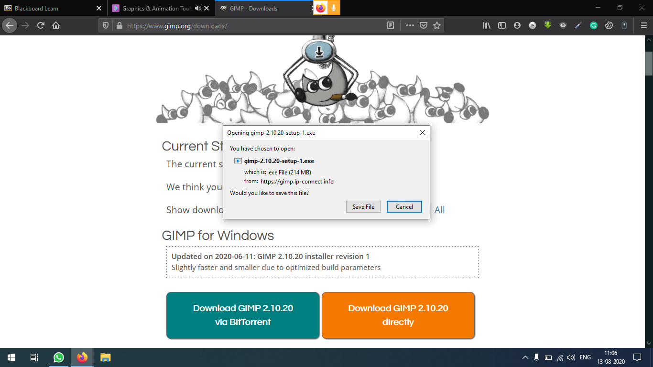

**Step 2:**Install GIMP.

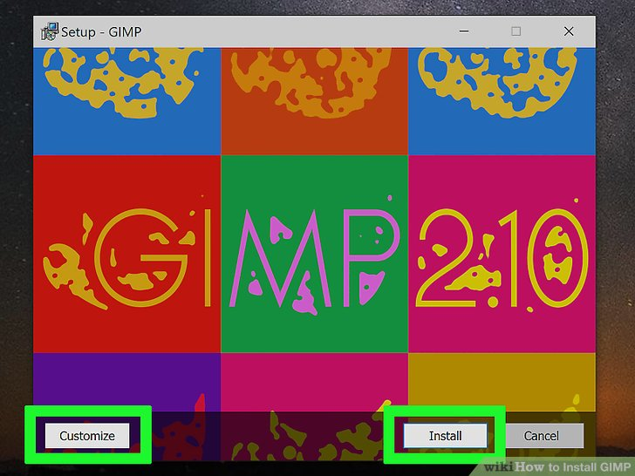

**Step 3:**Finish the installation.

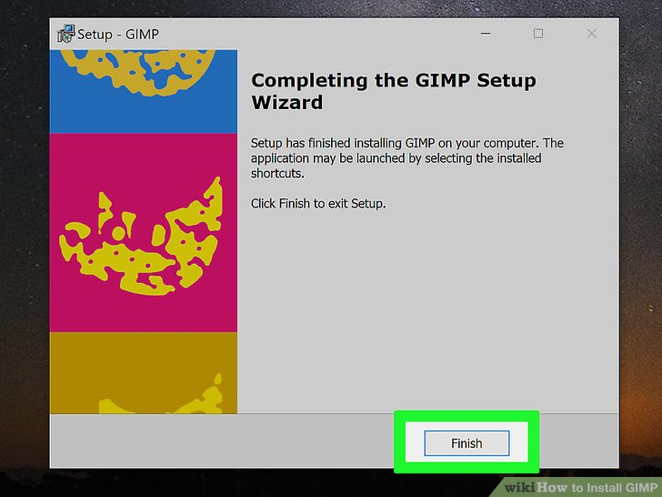

**Step 4:**Start using GIMP.

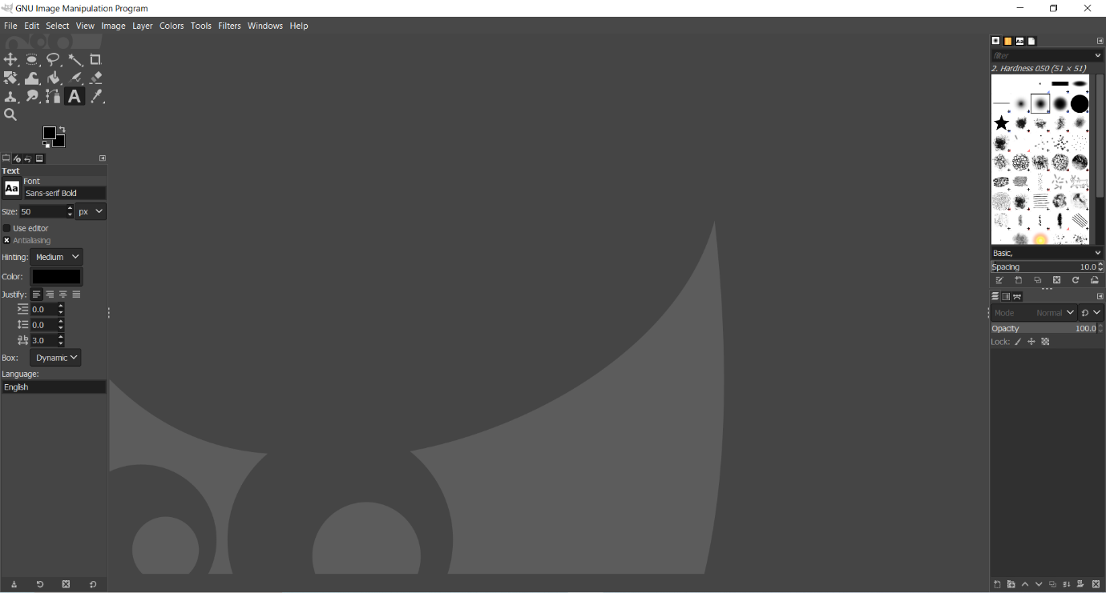

**Installation of BLENDER**

**Step 1:** Download BLENDER installer from blender.org/download/.

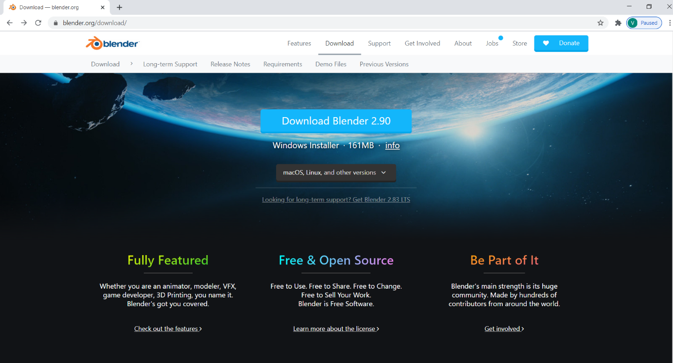

**Step 2:**Run the installer.

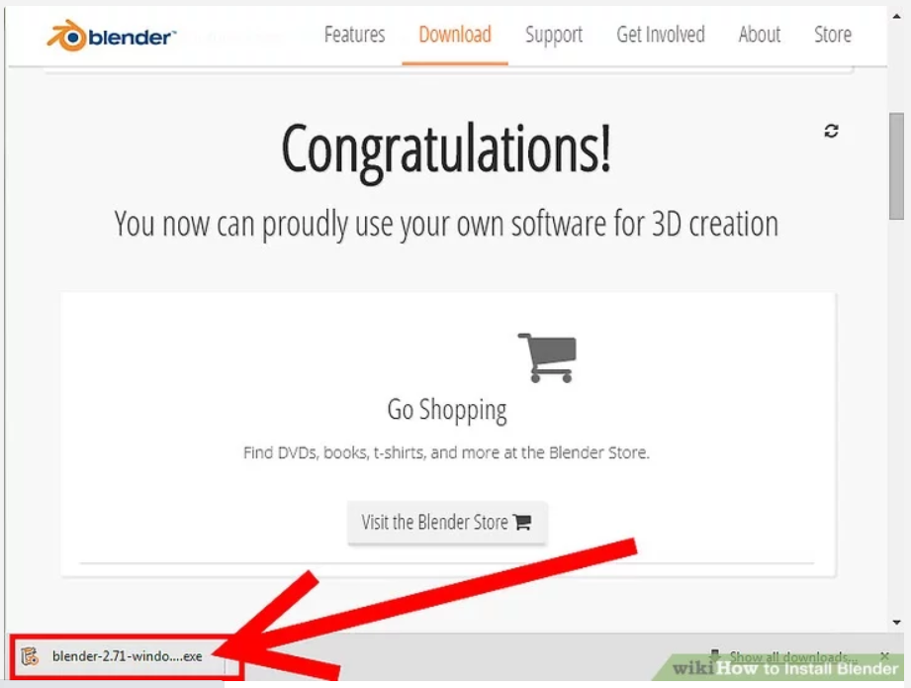

**Step 3:**Click on next.

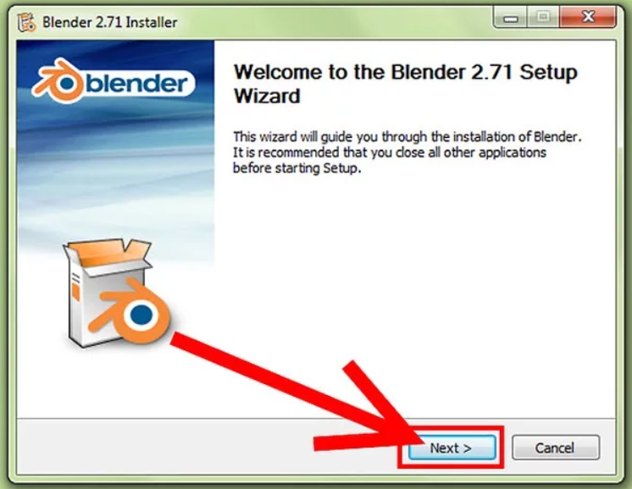

**Step 4:**Accept the license agreement.

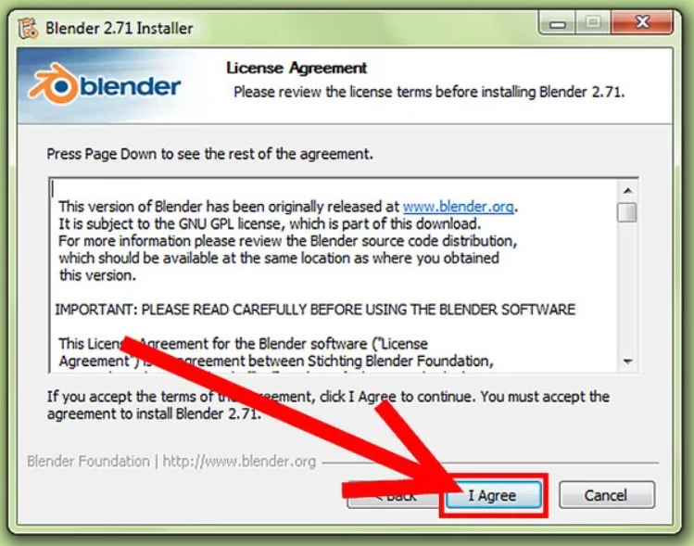

**Step 5:**click on install.

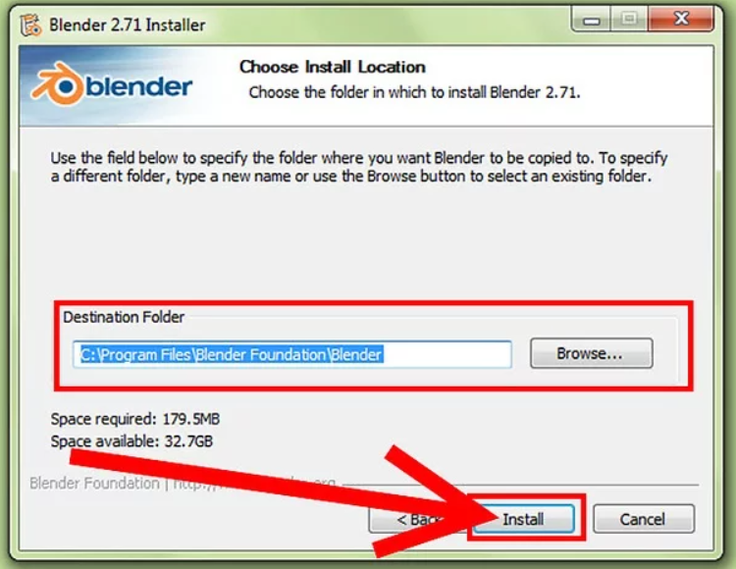

**Step 6:**Blender is installing.

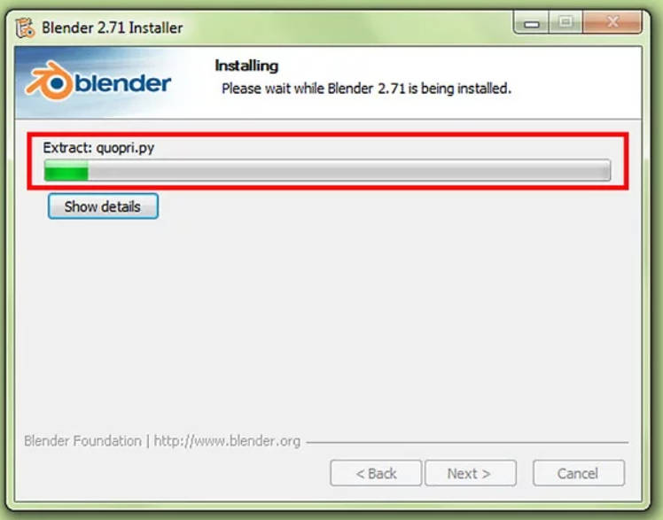

**Step 7:**Finish the installation.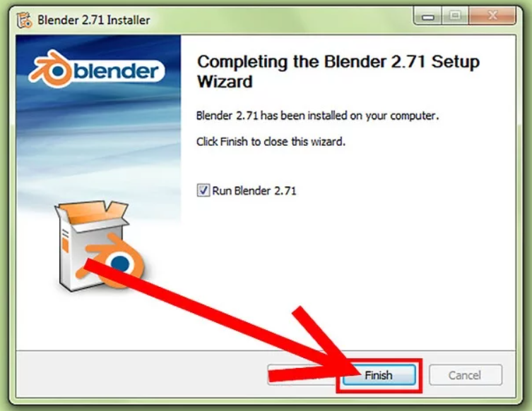

**Step 8:**Start using blender.

